Steel Buildings
Оглавление
1. Случайный поиск 1
2. Поиск " China steel building manufacturer" 2
3. Поиск "China dual slope double-floor prefabricated houses" 3
4. Близкие к Суйфэньхэ 4

1. Случайный поиск
Guangxi Hengxin Movable Building Co., Ltd.
№ | Model number | Brand name | Place of Origin | Material | Web | Price | Comment
1 | gxhx-622 | hx | Guangxi China | steel | www.gxhxhdf.en.alibaba.com | 25..50
2 | gxhx-144 | hx | Guangxi China |  |  | 25..50
3 | gxhx-141 | hx | Guangxi China |  |  | 43.3
4 | gxhx-6 | hx | Guangxi China |  | www.ecvv.com/company/hxprefabhouse/index.html
5 | gxhx-13 | hx | Guangxi China | metal |  | 1..5K USD
6 | gxhx-14 | hx | Guangxi China | metal |  | 1..5K USD | 858
7 | gxhx-18 | hx | Guangxi China | sandwich panel |  | 1..5K USD

1.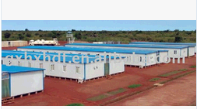 2.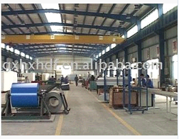 3.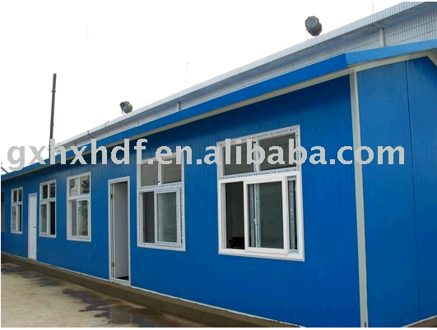
4.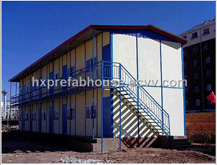 5.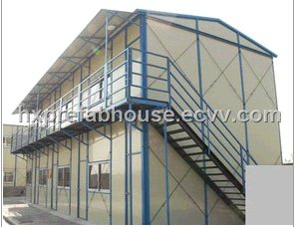 6.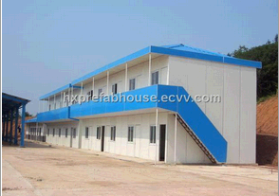 7.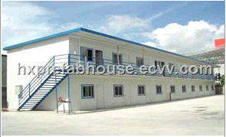

2. Поиск " China steel building manufacturer"
1 сайт: http://en.china.cn/selling-leads/Steel+Building

Список фирм, получающих 1-месячную рекламу на сайте КИТАЙ:
№ | Name | Origin Place | Web |  |  |  | Comment
1 | Beijing Baodu Steel Structure Co.,Ltd. |  | http://baodu8.en.china.cn/
2 | Qingdao Yili Steel Structure & Engineering Co., Ltd. |  | http://cnsteelstructure.en.china.cn/
3 | Henan hzz Iron & steel co.,ltd |  | http://hzzsteel1.en.china.cn/ |  |  |  | material
4 | Star Packaging Product (Suzhou) Co., Ltd |  | http://antistatic.en.china.cn/ |  |  |  | material
5 | Shandong Zerchen Energy Technology Co., Ltd. |  | http://jingta.en.china.cn/
6 | jingjiing Machinery Co.,Ltd |  | http://buildingmachine.en.china.cn/
7 | AMPAC International (Shanghai) Limited | Shanghai | http://ampacisl.en.china.cn/
8 | Beijing DCTH Steel Structure prerabicated house Co., Ltd. |  | http://prefabricatedhouse.en.china.cn/ |  |  |  | houses
9 | Weifang Henglida Steel Structure Co., Ltd. |  | http://lidasteelstructure.en.china.cn/
10 | DIUK ENERGY |  | http://diuke.en.china.cn/
11 | Conceiving Board-Manufacturing Co., Ltd. |  | http://cbcl.en.china.cn/
12 | Shanghai DL Tech & Trade Co., Ltd. |  | ???
13 | Ningbo Yutai Steel Structure Co., Ltd. |  | http://nysscl.en.china.cn/
14 | QingDao YiLi Steel Structure & Engineering Co.,Ltd |  | http://cathywon.en.china.cn/
15 | Asia Minmetals Machinery Co., Ltd. | Hong Kong | http://ammcl.en.china.cn/
16 | Wuxi Huajin Crane Co., Ltd. |  | http://publiccorp1065382764.en.china.cn/
17 | Zhejiang Guosheng Steel Structure Co., Ltd. |  | http://zgsscl.en.china.cn/
18

3. Поиск "China dual slope double-floor prefabricated houses"
1 сайт:

4. Близкие к Суйфэньхэ

№ | Company name | Origin Place | Web |  |  |  | Comment
1 | Jing'aoxing Light Steel and Color Plate Co., Ltd |  | http://www.jaxdchina.com/ | http://jingaoxing.en.china.cn

Портал о бизнесе в КНР (по-русски, грамотно)
http://russian.hktdc.com/

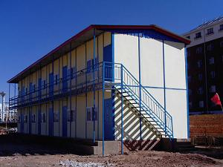
Dual slope double-floor prefabricated houses

